**Lab 2.1**

**Print**

**Name-Surname**………………………………......**Student No**........................................**Section (LAB)**……………

**Lab instruction**

1. Open VS code or JAVA IDE in your computer.
2. Use statement System.out.println(); to generate the output.
3. Create a new java class name **MyInfo.java**, then write a code to show the output following example.

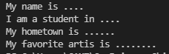

1. Share VS code screen and run the program to the teacher assistant (TA) to get the score.

**Checkpoint 1 For teacher or TA**

󠇀 Run “MyInfo” Program.

1. Create Area.java to help you calculate the area of each shape.

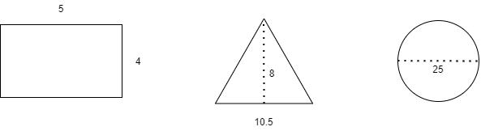

1. Share VS code screen and run the program to the teacher assistant (TA) to get the score.

**Checkpoint 2 For teacher or TA**

󠇀 Run “Area” Program.

--------------------------------------------End of Lab-----------------------------------------------